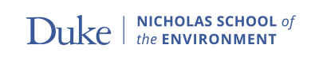
International Business Supplement

Applicant’s Name (Last First Middle):

The following questions will provide additional information about the business listed on your Need Access Application. Use 2021 Income Information and convert dollar amounts in US dollars if this business is not located in the United States. Please complete one form for each business.

Name of Business:

Address of Business:

- Date Business Commenced:
- Percentage of Business Owned by Parents:
- Number of Employees:
  - Of this number, how many are family members?
- Type of Business:
- Describe Product or Service:
- Gross Business Revenues (annual, 2015): $
- Business Expenses: (Itemize on a separate sheet): $
- Total Expenses: $
- Net Profit (Revenue less Expenses): $
- Business Assets:
  - Cash: $
  - Other Current Assets: $
  - Land and Buildings (present market value): $
  - Equipment / Fixed Assets (fair market value): $
- Total Business Indebtedness: $

Father / Stepfather’s Signature: Date:

Mother / Stepmother’s Signature: Date:

